ASSINGMENT 2 SEPTEMBER 2023

SOLUTION 2: 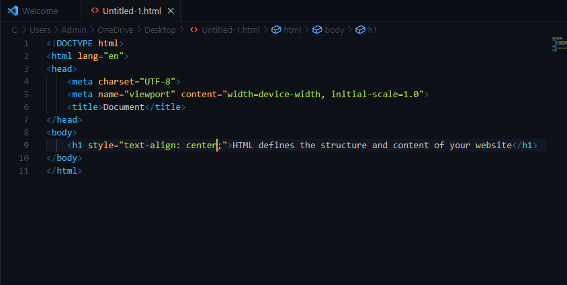

OUTPUT:

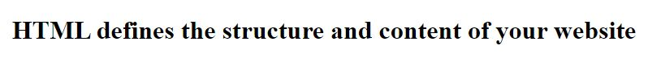

SOLUTION 2:

Comments in HTML serve as non-rendered text that provides information about the code for human readers.

They are useful for documenting your code, explaining its purpose, making notes, or temporarily disabling parts

of the code without deleting them. Comments are ignored by browsers and do not affect the rendering of the

webpage.

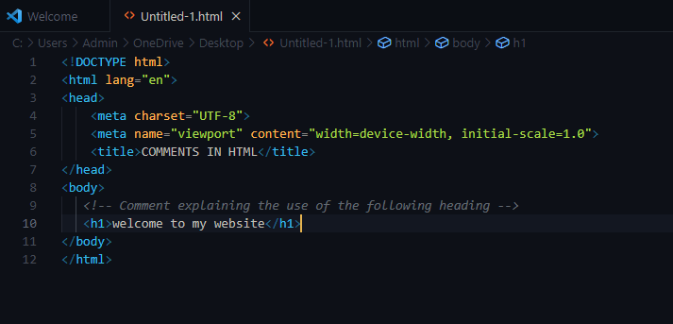

SOLUTION 3:

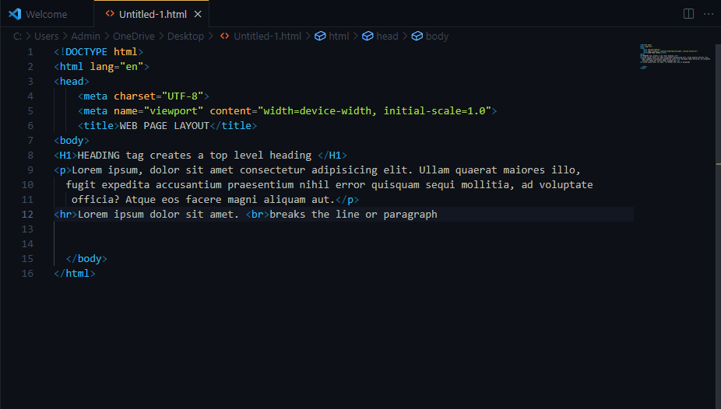

SOLUTION 4:

* Paragraph tag: An HTML tag is a snippet of code enclosed within angle brackets ("<" and ">") that defines the purpose and

structure of a specific element on a webpage. Tags are used to instruct the

web browser how to display the

content they enclose. Tags usually come in pairs: an opening tag and a closing tag, with the name of the

element enclosed within the tags.

Example: 

* Element tag: An HTML element is a complete unit that includes an opening tag, content, and a closing tag. It represents a

distinct part of a webpage's content or structure. Elements are composed of tags and the content enclosed

between those tags.

EXAMPLE: 

SOLUTION 5: The DOCTYPE declaration in HTML is a special instruction placed at the beginning of an HTML document to

specify the version of HTML being used. It ensures proper rendering and parsing by web browsers. The most

common declaration, <!DOCTYPE html>, indicates the use of HTML5, the latest version of HTML.